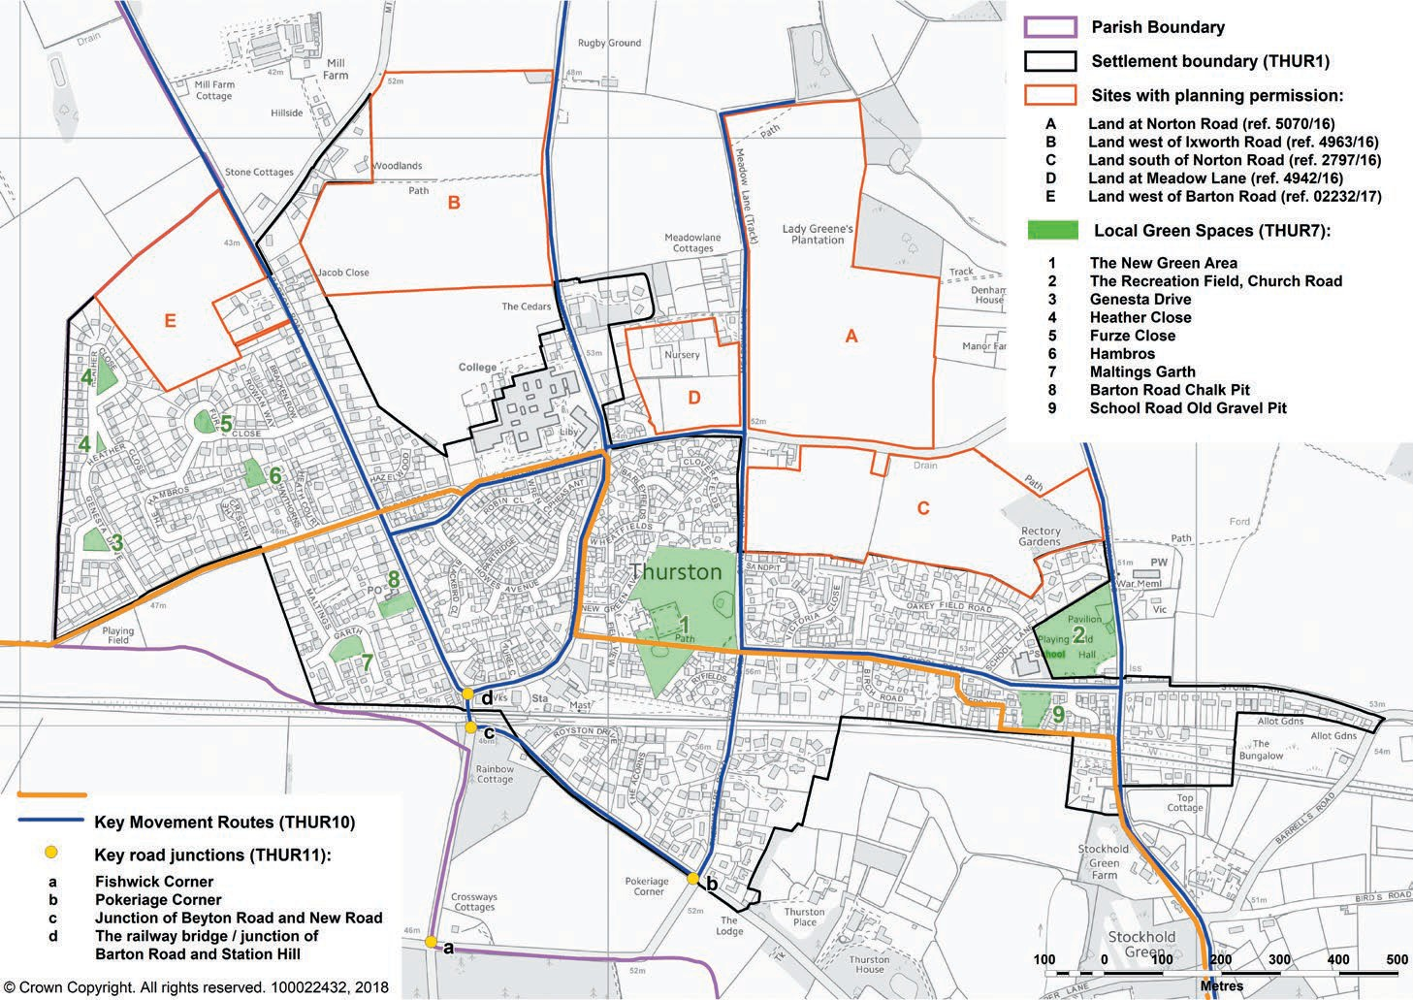

(ref. 2797/16 - 5010/16)
11

1

2

8
5
4
7
6

10

National Cycle Route 51
Site 9 is further along Beyton Road
3

Sites Analysed as possible sites for Recreational Facilities

Site Number | Location | Ownership | Site Assessment
1 | Land to the West of Ixworth Road – on land that has planning permission for a new school / land that might be surplus to educational requirements | As per Section 106 agreement | Slightly negative
2 | Land to the North of Norton Road - on land that has planning permission for a new school / land that might be surplus to educational requirements | As per Section 106 agreement | Neutral
3 | Land to the south of Beyton Road | Sir George Agnew/Bloor Homes | Neutral
4 | Heath Road Play Area | Rented by the Parish Council from Thurston Relief In Need Charity | Slightly negative
5 | Heath Road | Land held in trust by Thurston Relief in Need Charity | Neutral
6 | Thurston Primary School (old premises), School Lane | SCC / Diocese | Slightly positive
7 | Thurston Recreation Ground | Land held in trust by Thurston Parish Council | Slightly negative
8 | New Green Community Open Space Area – | Land held in trust by the New Green Community Trust | Slightly positive
9 | Plum Pudding Field, Beyton Road | Private ownership | Slightly negative
10 | Allotment Gardens, Beyton Road | Private ownership | Strongly negative
11 | Land to the East of Ixworth Road | Land owner / Gladman Developments | Slightly negative

