Friends of Thurston Library
Thurston Library on Norton Road is open for everyone in Thurston
and the surrounding area – adults and children

Visit the new Thurston Library Friends website
http://thurstonlibraryfriends.suffolk.cloud
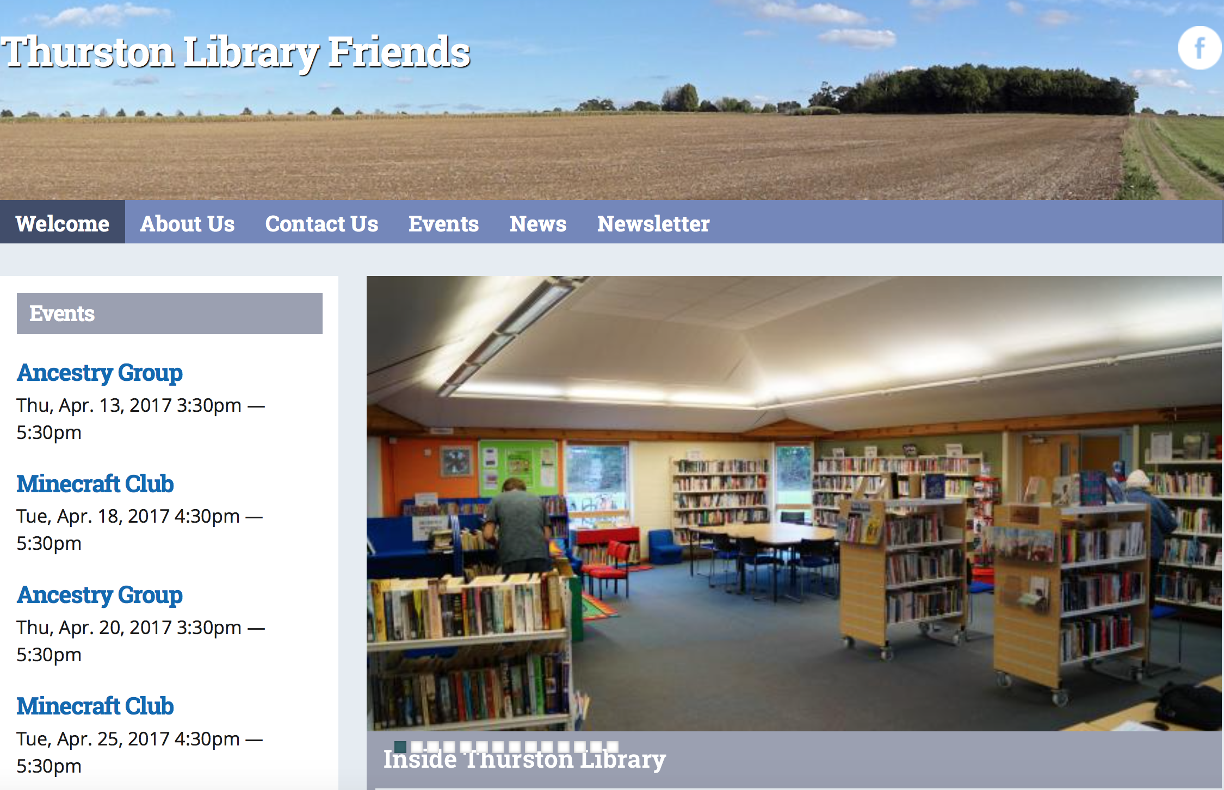

Use the website to find out the latest: what the library offers, what’s on, and how you can join our forward-looking, welcoming library

Friday 16 June
LIVE BBC Broadcast!
Jonathan Dimbleby and the
BBC Radio 4 Any Questions? Team
are coming to us.
Get your free tickets now.
See below for details.

Events coming up
Sunday 30 April and every Sunday, Lego Club:
Yes, here it is … fun for all!

Call in at the Library for details.

Thursday 4 May, 6.30pm for 7.30pm Charlie Haylock ‘An Eccentric Look at Suffolk’
Come to the Library: laugh, enjoy, have a drink and a hilarious evening with Charlie.
“Charlie can reduce audiences to tears of laughter as anyone who has seen his An Eccentric Look at Suffolk will tell you.”
Tickets, £5 each, from the Library 01359 235048, or Barbara Morris 01359 270697
An alcohol licence has been applied for. Doors open 6.30pm.

Thursday 25 May, 7.00pm Pauline Manders ‘My Suffolk, my books’
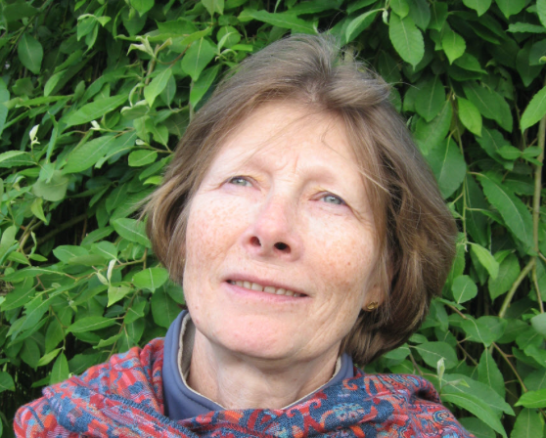
Our local author talks in the Library about how Suffolk makes the perfect setting for her murder and crime novels.

A free event. Tickets from the library

Friday 16 June, from 6.30pm BBC Radio 4 Any Questions? with Jonathan Dimbleby
– live national radio broadcast from Thurston Sixth Form, Beyton Campus
The Friends of Thurston Library with Thurston Community College are hosting this prestigious Radio 4 programme in the Thurston Sixth Form, Beyton Campus. We are delighted Radio 4 accepted The Friends’ invitation to broadcast this popular programme. The event is likely to be oversubscribed. Tickets are free (maximum 2 per person) on a first come first served basis from Thursday 27 April in the Library and Visitor Reception, Thurston Community College: come along; ask your questions!

Saturday 15 July, 7.00pm-10.30pm Mediterranean Supper with Musical Entertainment & Dancing
Great food and great entertainment make for another popular and enjoyable evening raising funds for St Peter’s Church and the library. Held in New Green. Tickets £15 each from the Library 01359 235048 or Barbara Morris 01359 270697. A bring your own drink event.

From Saturday 3 June - Bike Maintenance Saturday
To help get you out and about on your bikes this summer, Steve, Bill, Philip and a number of other volunteers are happy to share their knowledge of bike maintenance with you. So dust off your bikes and enjoy National Cycle Network route 51, which goes through the village – look out for the blue signs with red numbers, - and the wonderful quiet lanes around Thurston.
Informal introduction to your bike and enjoying cycling
Thursday 18 May at the Library, 7.30pm - 9pm – cake and drinks
Bike Maintenance Saturday – an opportunity to learn how to repair your bike
From 3 June at the Library, 10am - noon, and then the first Saturday of every month until October.
In association with:
For Friends Group information contact Richard Fawcett
01359 231363, or Peter Robinson 01359 232938

Thurston Library Manager: Cathy McDonald 01359 235048 Norton Road, Thurston, IP31 3PB
One of Suffolk Libraries
