Thurston Community Library and Friends Group

Live Music at the Library! Honey & the Bear Friday 21 October
Everyone welcome Doors open 7pm for 8pm Licensed bar and snacks
Tickets, £5, from the library or online at TicketSource: www.ticketsource.co.uk/date/273070
Honey & The Bear are a roots inspired duo from Suffolk. Their softly interweaving vocal harmonies and foot stomping rhythms combine elements of Folk, Americana, Country, Blues and whatever else takes their fancy. The multi instrumentalist pair, comprised of songwriters Jon Hart and Lucy Sampson, have been writing together since early 2014, performing at local festivals including Maverick and FolkEast in 2015.

Supported by Brian Hardman

This is a brand new venture for us, which we very much hope you will support and enjoy.

www.honeyandthebear.co.uk
You can hear them on youtube
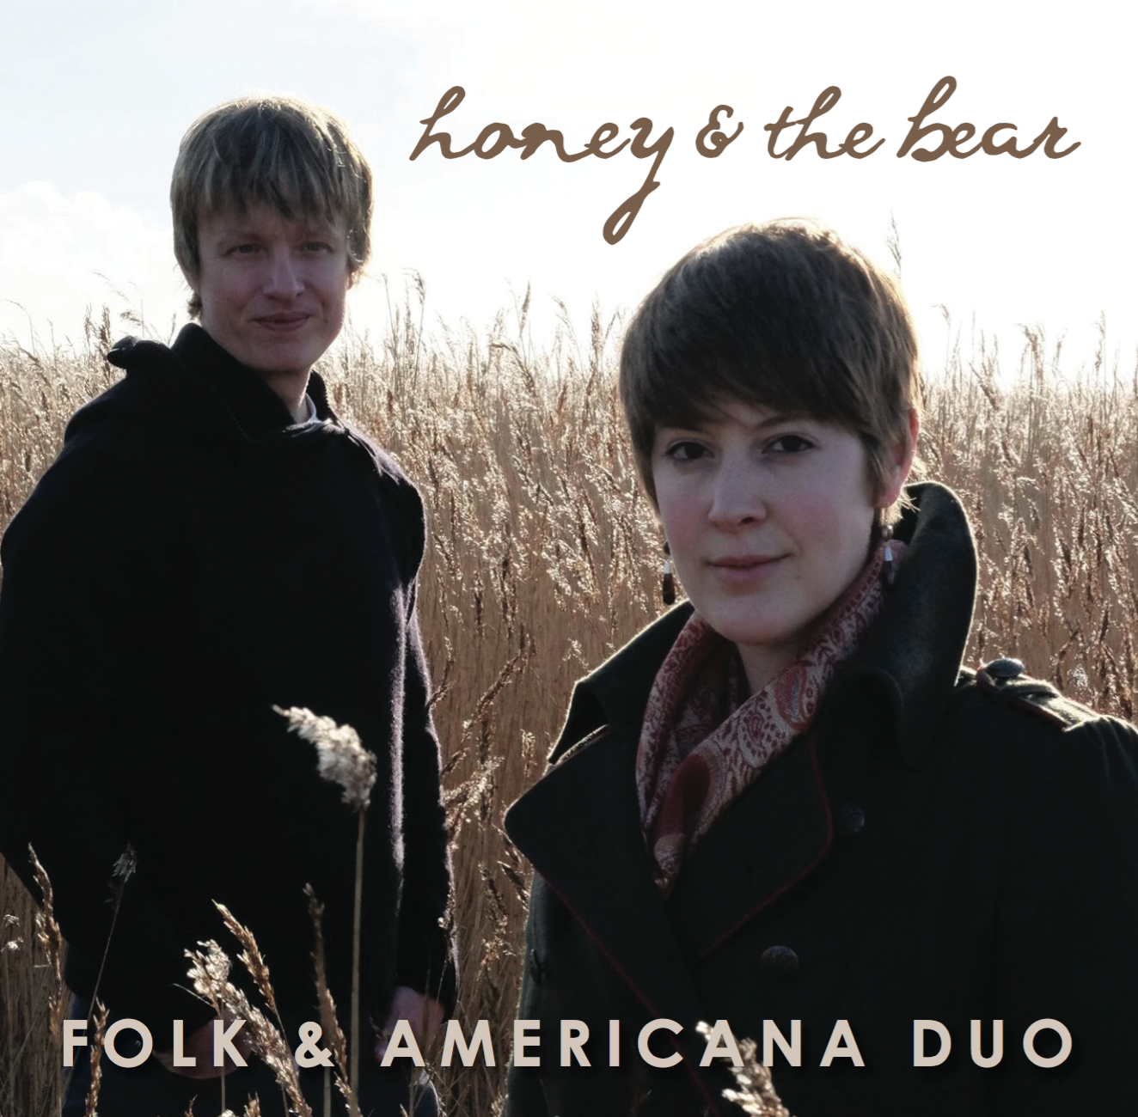

Annual General Meeting - Wednesday 9th November 7:00pm A free event: all welcome
Charlie Haylock, Cheese and Wine!
We have been very fortunate in securing Charlie Haylock, an excellent speaker for our AGM.
‘Charlie Haylock is one of Suffolk's leading entertainers. His informative and hilarious one-man shows are legendary in the county and his books have all been best sellers. Charlie can reduce audiences to tears of laughter with his story
An Eccentric Look at Spoken English is Charlie’s talk with us.
As usual, there will be cheese and wine after the meeting and Charlie’s talk, so do come and enjoy the evening.

Water Colour Group
A few people came forward last month wanting to join a group, so we are trying to arrange a date to bring them together and make further plans. We see this group as being very informal and self-sufficient. However, if you have expertise that you would like to share, we would love to hear from you! Please get in touch with Cathy, our librarian, if you would like to be included.

Code Club
Interested in a Code Club? We need adult help. Code clubs are for 9-11 year old children. Contact Cathy, our librarian.
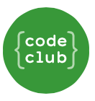

High Speed Broadband at the Library
The library now has high speed broadband, which is a free service for library users.

Contacts
Cathy McDonald, our librarian, 01359 235048 Thurston Library, Norton Road, Thurston IP31 3PB
Friends of Thurston Library: Richard Fawcett 01359 231363 or Anne O’Connell on 01359 231680

